System Calibration

The system calibration will be done with the obtained images and the MATLAB camera calibration toolbox.

The following are the steps taken to obtain the calibration result (with an accuracy analysis).

# Step 1: Convert the Images

The following code has been used to convert the “.png” to a “.jpg” image file type.

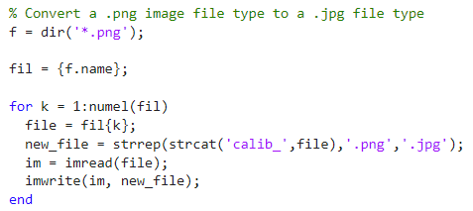

Figure MATLAB Code Snippet - Convert Image File Type

The “f = dir('*.png');” line, uses the dir function to list all of the files within the current directory that have a “.png” file extension type. Then it stores the list of file information in the variable “f”.

The “fil={f.name};” line extracts the names of the files from the file information that is stored within the variable “f” and then stores them in a call array named “fil”. Each element of the cell array contains the name of a “.png” file in the current directory.

The for loop iterates through a cell array fil, which contains the names of all ".png" files in the current directory. For each iteration, it retrieves the name of the current ".png" file, stores it in the variable file, and then generates a new file name new_file by adding "calib_" to the beginning of the file name and changing the file extension from ".png" to ".jpg." Afterward, it reads the image data from the current file using imread, and writes this image data to the new file new_file using imwrite. This process effectively converts each ".png" file in the directory to a ".jpg" format and renames it with an "calib_" prefix while preserving the original file's name. The loop continues until all ".png" files in the directory have been processed.

# Step 2: Extract the Grid Corners

The next step is to utilise the Camera Calibration Toolbox for MATLAB.

1. Start the calibration toolbox my using the **calib_gui** command into the MATLAB command window. Ensure the toolbox and desired calibration images are all within the same path.
2. **Select Mode of Operation**, click on **Standard (all images are stored in memory).**

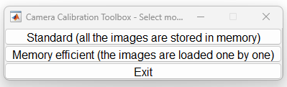

Figure Camera Calibration Toolbox - Select Mode of Operation

1. Then, the **Standard Version** of the Camera Calibration Toolbox window will open.
2. Select **Image Names**, type the base name “calib_image” and “j” to choose the image format.



Figure Image Names Settings

1. Then, the Calibration Images window will open.



Figure Calibration Images

1. Select, **Extract Grid Corners** and select all images for corner extraction. Leaving the wintx and winty values as default and using an automatic square counting mechanism.

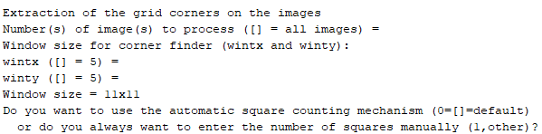

Figure Extraction of Grid Corners Settings

1. For all images, select the four inner grid corners of the checkerboard in the image. The first corner clicked will be the origin; use this same corner in all remaining images. Set dX and dY values to 14(mm). When prompted, select no for an initial guess for distortion.



Figure Image 1 Extract Grid Corner 1



Figure Image 1 Extract Grid Corner 2



Figure Image 1 Extract Grid Corner 3



Figure Image 1 Extract Grid Corner 4



Figure Image 1 Extracted Grid Corners

1. In the Camera Calibration Toolbox, select **Calibration** to calibrate the camera. Refer to Appendix B for the First Calibration results.
2. Next, select **Reproject on Images** to reproject the grid corners (refer to Appendix C).



Figure Reprojection Error of Image 1



Figure Reprojection Error of All Images



Figure Image Points and Reprojected Grid Points on Image 1

1. Next, select **Recomp. Corners** to recompute the grid corners in the images.

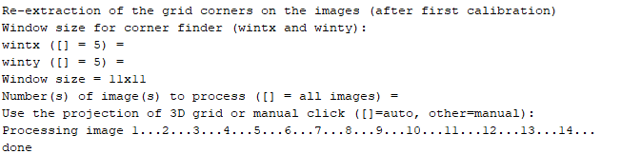

Figure Recompute Corners Settings

1. In the Camera Calibration Toolbox, again, select **Calibration** to recalibrate the camera using the same setting as previously used. Refer to Appendix B for the Second Calibration results.
2. Next, select **Show** **Extrinsic** to view the extrinsic parameters for each image.

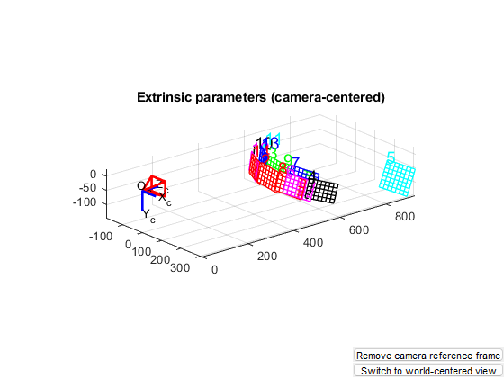

Figure 15 Extrinsic Parameters (Camera-Cantered)

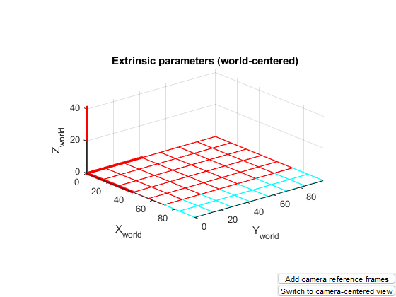

Figure Extrinsic Parameters (World-Cantered)

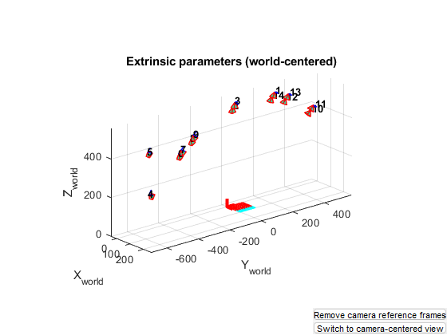

Figure Extrinsic Parameters (World-Cantered) with Added Camera Reference Frame

1. Save the calibration data.

# Appendices

## Appendix A – MATLAB Code for Converting the Images

% Convert a .png image file type to a .jpg file type

f = dir('*.png');

fil = {f.name};

for k = 1:numel(fil)

file = fil{k};

new_file = strrep(strcat('calib_',file),'.png','.jpg');

im = imread(file);

imwrite(im, new_file);

end

## Appendix B – Calibration Results

### First Calibration

Calibration results after optimization (with uncertainties):

Focal Length: fc = [ 631.16766 631.00584 ] +/- [ 121.96970 116.74740 ]

Principal point: cc = [ 320.70321 242.93117 ] +/- [ 61.64725 74.49633 ]

Skew: alpha_c = [ 0.00000 ] +/- [ 0.00000 ] => angle of pixel axes = 90.00000 +/- 0.00000 degrees

Distortion: kc = [ -0.06743 0.19043 0.00832 -0.00467 0.00000 ] +/- [ 0.34898 1.14260 0.05061 0.03568 0.00000 ]

Pixel error: err = [ 0.46812 0.64955 ]

Note: The numerical errors are approximately three times the standard deviations (for reference).

Recommendation: Some distortion coefficients are found equal to zero (within their uncertainties).

To reject them from the optimization set est_dist=[0;0;0;0;0] and run Calibration

### Second Calibration

Calibration results after optimization (with uncertainties):

Focal Length: fc = [ 633.52615 633.45627 ] +/- [ 122.51386 117.11502 ]

Principal point: cc = [ 321.47181 241.46507 ] +/- [ 58.04011 74.57180 ]

Skew: alpha_c = [ 0.00000 ] +/- [ 0.00000 ] => angle of pixel axes = 90.00000 +/- 0.00000 degrees

Distortion: kc = [ -0.08680 0.28603 0.00847 -0.00413 0.00000 ] +/- [ 0.35488 1.20329 0.05110 0.03337 0.00000 ]

Pixel error: err = [ 0.47096 0.65015 ]

Note: The numerical errors are approximately three times the standard deviations (for reference).

Recommendation: Some distortion coefficients are found equal to zero (within their uncertainties).

To reject them from the optimization set est_dist=[0;0;0;0;0] and run Calibration

## Appendix C – Reprojection of Grid Points on Images



Figure Image Points and Reprojected Grid Points on Image 1



Figure Image Points and Reprojected Grid Points on Image 2



Figure Image Points and Reprojected Grid Points on Image 3



Figure Image Points and Reprojected Grid Points on Image 4



Figure Image Points and Reprojected Grid Points on Image 5



Figure Image Points and Reprojected Grid Points on Image 6



Figure Image Points and Reprojected Grid Points on Image 7



Figure Image Points and Reprojected Grid Points on Image 8



Figure Image Points and Reprojected Grid Points on Image 9



Figure Image Points and Reprojected Grid Points on Image 10



Figure Image Points and Reprojected Grid Points on Image 11



Figure Image Points and Reprojected Grid Points on Image 12



Figure Image Points and Reprojected Grid Points on Image 13



Figure Image Points and Reprojected Grid Points on Image 14